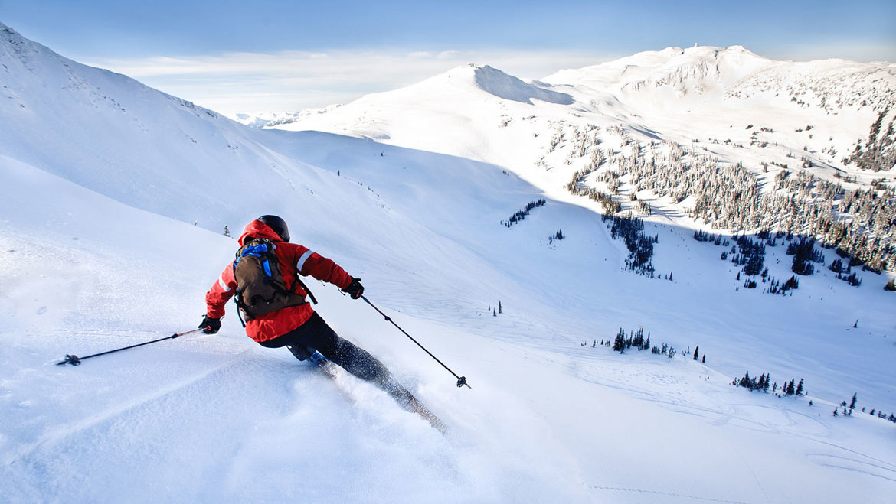

Big Mountain Resort

Revenue increase recommendations

Kunal Agarwal | Guided Capstone | 15-06-2020

# Problem Identification

* The Big Mountain Resort started in 1947.
* It has 11 lifts, 2 T-bars, 1 magic carpet to service visitors across the vast 3000 acres terrain with annual snowfall of 333 inches.
* The base elevation is 4,464 feet, and the summit is 6,817 feet with a vertical drop of 2,353 feet.
* Installing a chair lift has incurred an additional operating cost of $1,540,00 this season.
* The investors now seek to recoup these costs in the upcoming season by increasing the revenue without reducing profit margin of 9.2%.

# Problem Statement

How can we increase the resort’s revenue by at least $1.5M by the end of this season, by remodelling our operational services, extending our working time to draw more visitors, and predicting an optimal ticket price?

# Data Used

The dataset used consists of following features of other commercial Ski Resorts in the country:

* terrain standards – summit height, base height, skiable area, etc.
* operational services – lifts, trams, chairs, etc.
* ticket prices – weekday & weekend
* night skiing availability
* days opened last year – and predicted days open in upcoming season

# Machine Learning Model Applied

* As the task is focused on increasing the revenue for the resort, this can be classified as a Supervised Regression model.
* Data is split into training and testing datasets on a 75/25 basis.
* AdultWeekend – the ticket price for an adult on a weekend, is selected as our response variable.
* A Linear Regression model is run over the cleaned training data and our response variable.

# Model Deliverables

* Predicted ticket price for our resort, given other features.
* Top factors which most influence the response variables.

# Final Recommendations

Summit Elevation from ground level is the strongest feature among all, which leads to higher vertical drop and helps creating a better experience for our skiers.

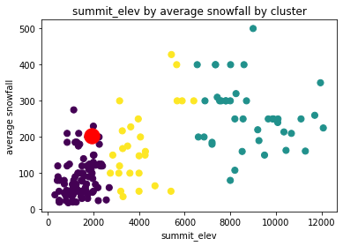

Snowfall, which is basic necessity for any ski resort, is quite dependent on the resort’s elevation and there is maximum snowfall on highly elevated terrains.

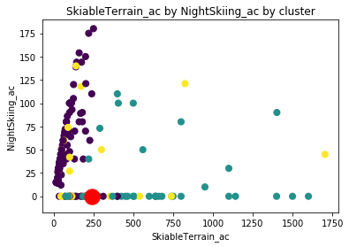

Night skiing is a relatively new feature which is only provided by a limited resorts so far. Fortunately, data shows that night skiing can be hosted even on low heighted terrains. Hence, we should host night skiing for attracting new customers which shall help in maximizing our revenues.

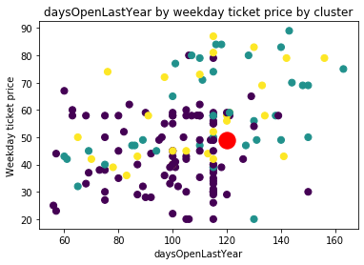

Opening our resort for longer number of days in the upcoming season allows us to draw more customers and increase revenue by hiking the ticket price.

# Model Performance

* Explained Variance Score = 0.543 ~ 54.3%
* Mean Absolute Error = 7.257

# Predicted Ticket Price for our Resort

Given all the other features at the Big Snow Resort, our model here predicts its optimal ticket price for each adult on a weekend as $55.

However, the actual ticket price at the resort is just $49.